Yield-MAN (RDB)
MySQL 5.0 to MySQL 5.1 upgrade noted

Date: 26 January 2010

The aim of this document is to provide a short description of the steps to upgrade from MySQL 5.0 to MySQL 5.1 for RDB customers using a MySQL GEXDB database running on Windows.

- Download the latest MySQL 5.1 installation package (with installer recommended).
- Stop the MySQL 5.0 Windows service:
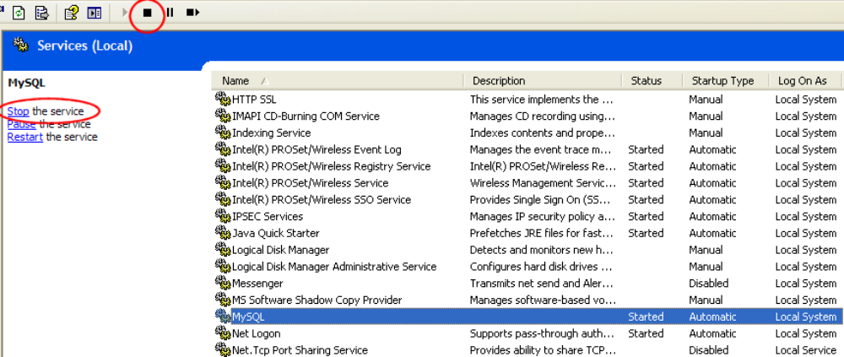
- Edit the MySQL 5.0 Windows service properties, and set the ‘Startup type’ to ‘Manual’
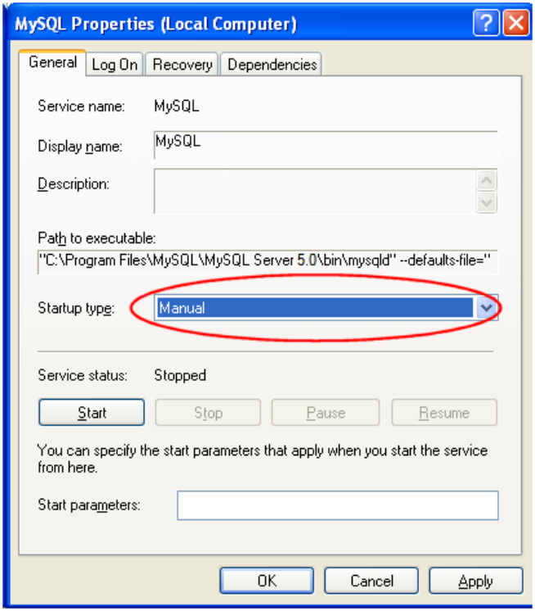
- Install MySQL 5.1, don’t execute the instance configuration wizard:
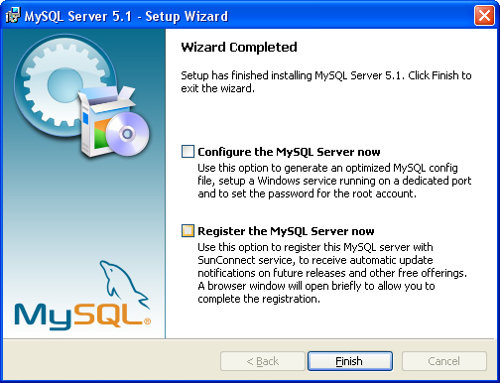

- Copy your MySQL configuration file (my.ini) from your MySQL 5.0 installation directory to your MySQL 5.1 installation directory.

- Edit the MySQL 5.1 configuration file just copied (my.ini), and set the base directory so that it points to your MySQL 5.1 installation:
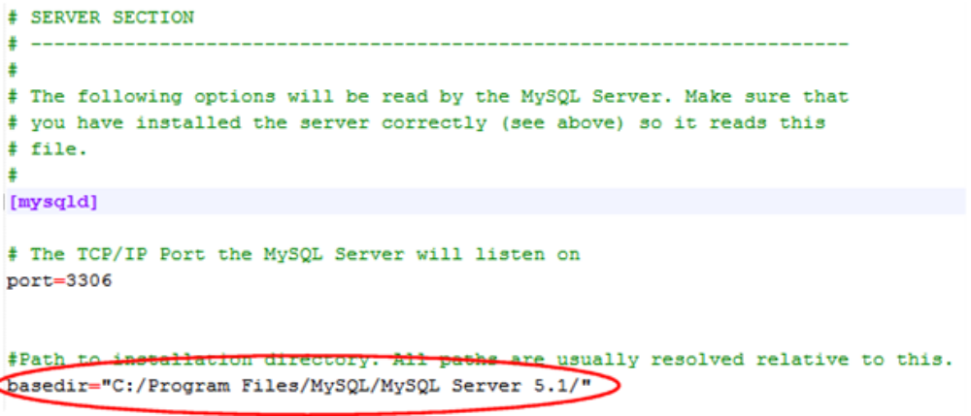

- Install the MySQL 5.1 Windows service:

  - Open a DOS command prompt
  - Cd to your MySQL 5.1 bin directory
  - Execute following command:
prompt> mysqld --install MySQL51 --defaults-file=<full path to your MySQL 5.1 my.ini file>
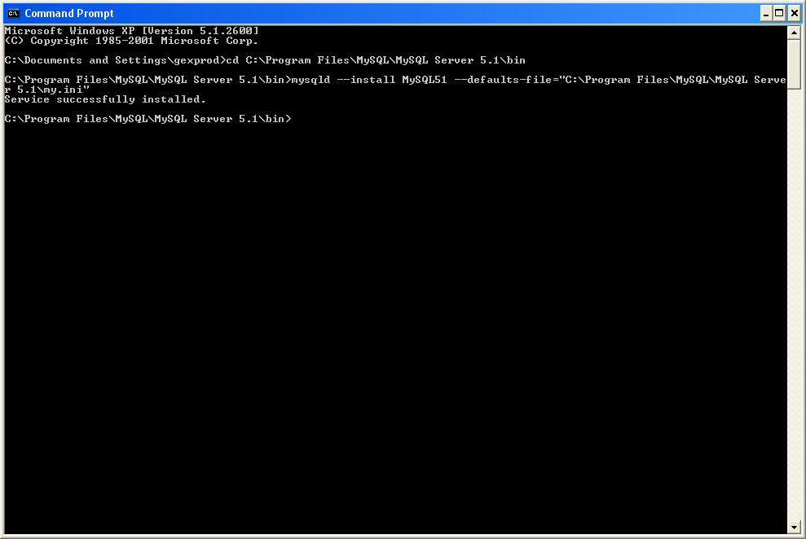

- Start the MySQL51 Windows service:
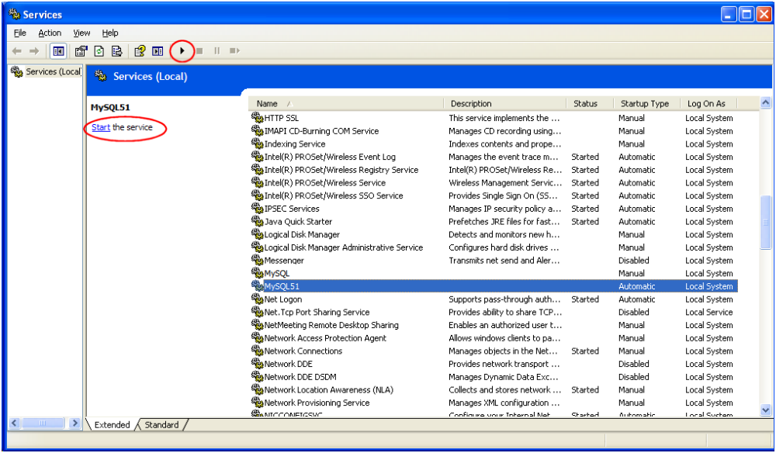
- Run the mysql_upgrade tool:
  - Open a DOS command prompt
  - Cd to your MySQL 5.1 bin directory
  - Execute following command:
prompt> mysql_upgrade.exe –p>mysql_upgrade.log (enter root password when prompted)
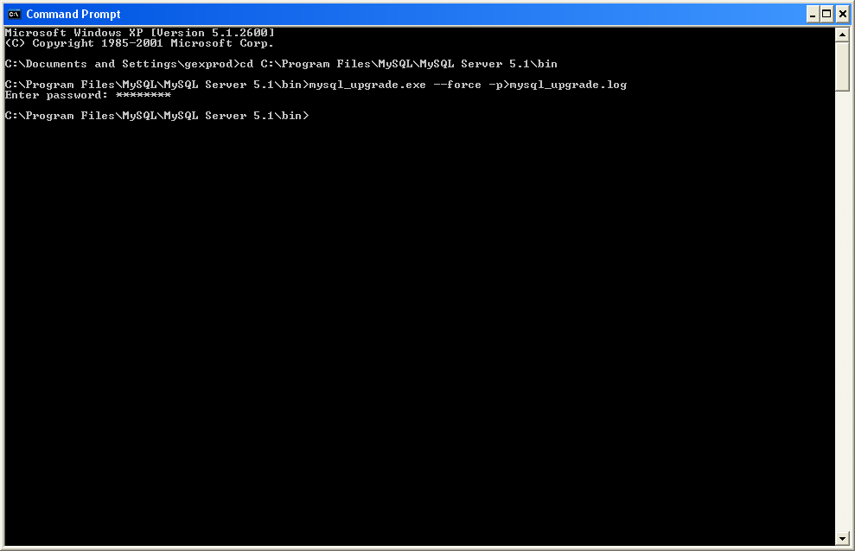
- Check the mysql_upgrade.log file for any issues.
Following type of error messages can be disregarded, as they correspond to a known MySQL issue, but with no consequence on the MySQL 5.1 successful migration:
mysql.<something>_log
Error : You can't use locks with log tables.
status : OK
- Check the error log file for issues: <MySQL data directory>/<computer name>.err

